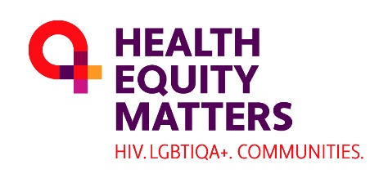

LGBTIQA+ Health Community Consultation

Think Change Resolve (TCR) is working with Health Equity Matters (formerly AFAO) to conduct a national consultation to understand the primary health care needs, experiences and priorities of LGBTIQA+ communities.
Our project aims to make recommendations to improve primary health care to better meet the needs of LGBTIQA+ people across the country.

How to get involved
Our consultation will be running over May to June 2023 and we want to hear from the whole diversity of our communities, including all of the LGBTIQA+ and those in urban, regional, remote locations; old and young; First Nations; people from diverse ethnic backgrounds and people with disability. There are a number of ways you can get involved.

Complete the online survey
An online survey will be open from 1 May - 18 June 2023. All LGBTIQA+ community members who access primary health care are encouraged to complete the survey so we can hear about the diversity of experiences of health care. The survey is also open to parents and carers of queer and/or gender diverse children and young people.
Take the online survey.

Attend an in-person or online workshop
We are conducting workshops both in person and online at the following dates/times. Attendees will go into the running to win a $100 JB Hi-Fi voucher. To register your attendance for a workshop, please click on the registration link for the selected session below.

Online consultations - Registration essential​​
- 23 May 2023, 1:30pm-2:30pm AEST online workshop for trans and gender diverse people
- 24 May 2023, 11am-12:00pm AEST online workshop for young LGBTIQA+ people (aged 16-25)
- 24 May 2023, 2pm-3pm AEST online workshop for LGBTIQA+ people with disability
- 25 May 2023, 10am-11am AEST online workshop for LGBTIQA+ people from culturally and linguistically diverse backgrounds
- 26 May 2023, 12:30pm-1:30pm AEST online workshop for LGBTIQA+ community members
- 30 May 2023, 12pm-1:00pm AEST online workshop for lesbian, bisexual and queer women
- 31 May 2023, 12pm-1:00pm AEST online workshop for parents of queer and/or gender diverse children and young people
- 6 June 2023, 12pm-1:00pm AEST online workshop for LGBTIQA+ older people
- 16 June 2023, 12pm-1:00pm AEST online workshop for LGBTIQA+ community members
- 19 June 2023, 3pm-4pm AEST online workshop for LGBTIQA+ community members

Planned in-person consultations (exact times and location TBC)
- 26 May 2023 Hobart consultations (contact emily@thinkchangeresolve.com)
- 4 June 2023 Ipswich consultations
- 4 June 2023 Hervey Bay consultations
- 7-9 June 2023 Northern NSW consultations
- 9-10 June 2023 Brisbane consultations
- 13-15 June 2023 Melbourne consultations
- 20-21 June 2023 Bendigo consultations

Please email ruth@thinkchangeresolve.com to register your interest in attending any in-person consultations​

Chat with us 1:1
If you would be more comfortable with a confidential 1:1 discussion by Zoom or phone with one of our project team members, you can book in using the link below.
- Chat with Emily Scott (Emily is particularly interested in speaking with lesbian, queer and bisexual women, older people and parents of trans, gender-diverse or queer children)
- Chat with Emma Shinozaki
- Chat with Gus Heesh (Gus is particularly interested in speaking with young people, and trans, gender diverse and non-binary people)

More sessions will be available soon, please email emma@thinkchangeresolve.com to register your interest in a 1:1 consultation.
​

Share the links to our survey and registration form with your networks
​
We would love for you to share our survey link and registration form link to your networks via email, e-newsletter and/or social media.
Download suggested wording and the social tile (DOCX, 3.3MB)

Contact us for more information
We want to hear from as many people in our communities as possible throughout this project, from health providers and clinicians to LGBTIQA+ primary health users. If there are other ways you would like to be involved or you have questions about the project, get in touch with the Project Manager, Emma Shinozaki via emma@thinkchangeresolve.com

Our Team
We are a diverse and highly skilled team who have extensive experience in the health care sector and represent many facets of the LGBTIQA+ community.

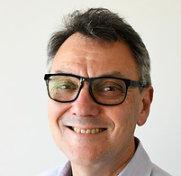

Robert Griew
Project Director
Robert Griew (he/him) is an expert in public health policy, having held CEO level roles across the sector. His specialised knowledge is complemented by a wealth of experience in management consultancy and leadership roles. He has formerly held roles as Secretary of NT Dept Health & Community services, head of Pop Health, Aged and Community Care and Indigenous Health Divisions in the Australian Government, Associate Secretary of Departments of Education and Industry, Robert was the CEO of ACON for the latter part of the 1990s when the board led a process to pivot toward community health. He has extensive experience working with Aboriginal and queer communities and organisations. In a former role, Robert led a team drafting the 8th national HIV and associated other BBV/STI strategies.

Shane Houston
Senior Associate
A Gangulu man from Central Queensland, Shane Houston (he/him) has a long-standing interest in culturally competent services and systems, and in health economics – especially in finding greater fairness in how systems allocate and use resources. Shane has held senior positions in the Aboriginal community-controlled health, public and university sectors, including as the first CEO of the organisation now known as NACCHO, foundation CEO of Tharawal ACCHO, head of Aboriginal health in both WA and NT governments, and Deputy VC University of Sydney. His PhD in economics focused on the implications of marginalised community preferences on health service resourcing and design which will be invaluable to this project.

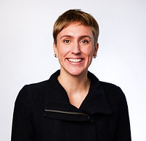

Emily Scott
Associate
Emily Scott (she/her) is an experienced management consultant, having spent 5+ years at Nous Group working with Robert Griew on health and human services projects. Her work at Nous included: national strategies for bloodborne viruses and sexually transmissible infections; AFAO Five Year Strategy; LGBTIQ+ Legal Service (Victoria) Strategy; and redesign of NSW Child Wellbeing and Child Protection system. As an independent consultant, she led a project with AFAO's Health Subcommittee to develop a series of options for AFAO to sustainably expand into aged and community care. She holds undergraduate degrees in Science (Biology) and Law and is an MBA graduate from AGSM @ UNSW Business School, where she was awarded Class Dux. She is extensively involved in the LGBITQ+ community including as Board Director and former CEO of Out for Australia, Board Director for International Gay and Lesbian Aquatics Association (IGLA) and Director of Pride@AGSM. She was awarded an AFR 100 Women of Influence for her contribution to LGBTIQ+ communities and mental health in 2019.

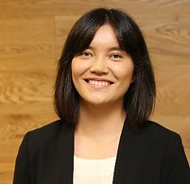

Emma Shinozaki
Project Manager
Emma Shinozaki (she/her) has a background in public policy and regulation, with skills in policy analysis, development and implementation, project management and stakeholder engagement. She has experience spanning across the public and private sectors in disability policy and quality/safeguarding, and with supporting community service organisations in governance, standards and compliance. Emma is passionate about delivering quality through human-centered approaches.

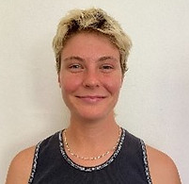

Gus Heesh
Advisor
Gus Heesh (they/them) is a research assistant and honours student at UNSW. They have experience working in primary healthcare settings and work as academic staff at UNSW in the School of Medicine. Gus is currently completing an honours project titled; ‘Understanding Sex and Gender in Anatomy; Current Profile and Gap Assessment’ as part of their undergraduate Medical Science (Anatomy) degree about intersex inclusivity in anatomy education. Their honours research project has a particular focus on the urgent need to present sex and reproductive anatomy as a spectrum in medicine programs with the intent to influence clinical practice, health outcomes for people with intersex variations and university teaching frameworks. Gus has a deep commitment to improving accessibility and health outcomes for all LGBTQIA+ people and centering LGBTQIA+ voices in discussions of the future of healthcare in Australia.

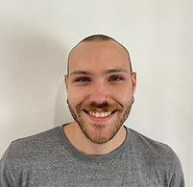

Mike Hitch
Consultant
Mike Hitch (he/him) is a consultant, digital campaigner, editor and LGBTIQA+ activist, with a background in media, communications and journalism. Mike has worked for various local and mainstream LGBTIQA+ publications, including the Star Observer magazine, Altmedia, the Sydney Sentinel and DNA Magazine. Specialising in writing about politics, social justice, and activism with a ‘youth’ focus, Mike's work involving First Nations and Queer communities has given him a wealth of community connections and contacts across the country, and in all areas of the LGBTIQA+ spectrum.

